PUBLIC REAL ESTATE AUCTION
Lycoming County - Washington Twp.
22 Acre Dairy Farm, 56 tie stalls, 5 bedroom home
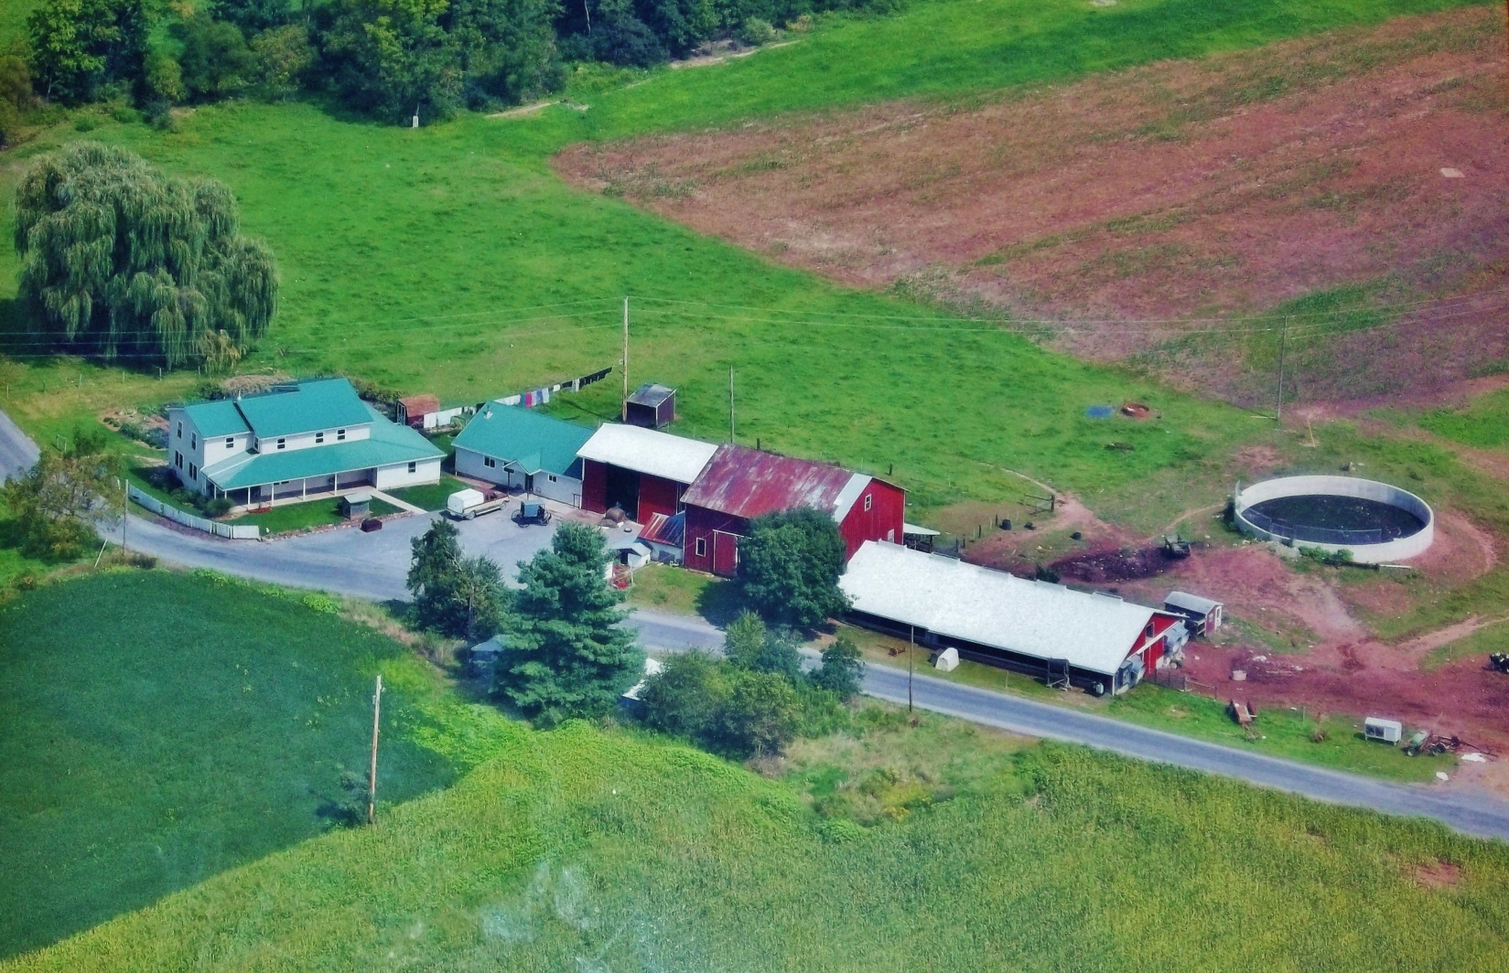
Aug. 27, 2014 @ 1:00 P.M.
527 Ireland Rd. Allenwood PA 17810

Directions: From Elimsport N. on Rt. 44 to straight on Gap Rd. to right on Leisure Acres Rd. to right on Ireland Rd. to property on right.
Comments: 22 acre farm in White Deer area, large 5 bedroom farm house, Dairy barn w/ 56 tie stalls, Petersheim cow mattress, tunnel ventilation, side curtains, bank barn for hay storage, 12’x54’ concrete manure storage, 25’x55’ 5 stall horse barn, 20’x44’ lean to with box stalls, 29’x40’ insulated shop. Land is mostly tillable & lies generally level. Come take a look at all the infrastructure. Come prepared to buy, great opportunity. Note: Deutz diesel, air compressor, vacuum pump & 2 cooling compressors to be sold separately following the sale of real estate
Open House Dates: Tue July 29th. 5:00 to 7:00 & Sat. Aug. 2nd. 1:00 to 4:00. Call 717-629-6036 for more information or a private showing
Terms: Settlement on or before Oct. 24, 2014. $20,000.00 down payment on the day of the auction. Transfer taxes to be paid by the buyer. Real Estate taxes to be prorated. Attention Realtors: 1% Broker Participation offered to Realtors with a buyer, your buyers must be preregistered.
For additional pictures go to Auction Zip .com ID # 23383
717-786-8000
Auctioneer: Attorney:
J. Meryl Stoltzfus Scott Williams
AU # 005403
717-629-6036
Sellers: Isaac K. Stoltzfus

Satellite View

