PUBLIC AUCTION
Oct. 20 @ 9:00
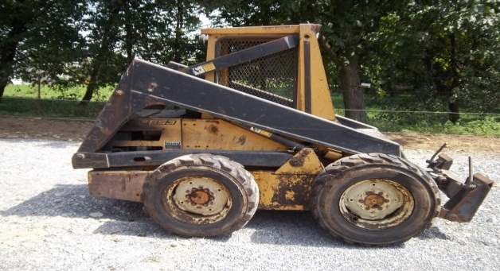
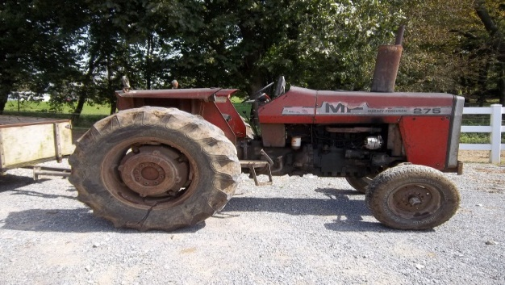
Tractor : Skid loader :Welding Shop Liquidation : Household
540 Todd Rd. Honey Brook PA 19344
Directions: from Honey Brook take Rt. 10 North to second road on the right. First place on the right.
Agriculture: 275 Massy Ferguson tractor, 540 RPM dual remotes, runs good; L553 NH skid loader, runs good; 8x11 dump trailer; 4x8 off road trailer; PTO shafts; Massey Ferguson Filters; Nylon tow rope;
Shop tools: Black max Air Compressor (50 gal. upright); Miller Matic welder 300 3ph; Acorn welding table; sheet metal table; large metal cutting shears, 3ph; Grizzly metal cutting band saw; Fleetwood 5 spd. drill press; 20 ton Hyd. Press; pipe bender; parts washer; 1,000 lb. chain hoist; torch; propane forge; Allen Bradley 3ph motor; misc. motors 3ph & 110; JHM Anvil; Universal & Quickie Attach, jigs & parts for buckets, bale spears & pallet forks; Elec. angle grinders, large & small; Handyman jack; 2 ton floor jack; bench vise; bench grinder; creeper; trailer jack; wood stove; Alum ladders; ½” socket sets; tap & die set; C clamps; wrenches; hammers; organizers; air purifier
Lawn & Garden: Tecumseh 8hp generator (like new); HRX217 Honda mower, walk behind, easy start; Troy built horse rototiller w/ Honda G300 engine; Stihl FS55RC weed eater; Echo weed eater; garden tools; picnic table; camping canopy
Furniture: Kienzle Mantle clock; Early Parfait; Hutch; Corner hutch (glass front); Bedroom Suite; Blanket chests; New Home sewing machine; Quilting frame; Sofa; drop leaf table; high chairs; crib; children’s table; child’s toy chest; rocking chairs; chairs & tables; a complete set of church folding benches; card table
Books: Lots of Christian books, early & new; Handyman, Gardening, Medical books; Pathway Publisher Magazines; 3’X6’ Anabaptist Mennonite Time Line
Kitchenware: Frigidare- refrigerator; Victoria Strainer; Roaster; stainless cookware; stainless pressure cooker; apple peeler; cherry stoner; drainer racks; lamps; 1950’s dishes; stone crocks; glass neck jars; Tupperware; misc. early dishes & glass ware; misc. kitchenware
Misc: Electrolux sweeper; doilies; Homemade hall carpets; feathered pillows; early blankets & table cloths; baskets; suitcases; children’s toys; bed linens
Many more items too numerous to mention.

J. Meryl Stoltzfus Terms by:
www.beiler-campbell.com 888-209-6160
Lic. #AU005403 John Omar &
717-629-6036 Naomi Stoltzfus

