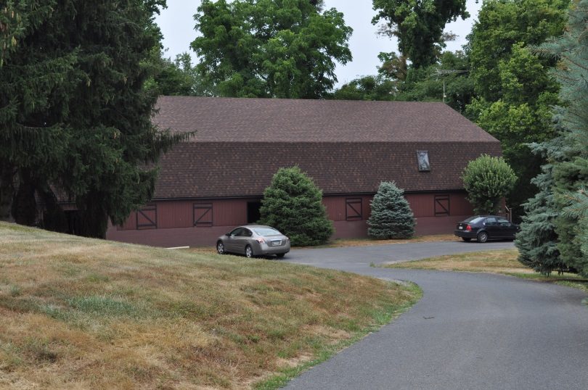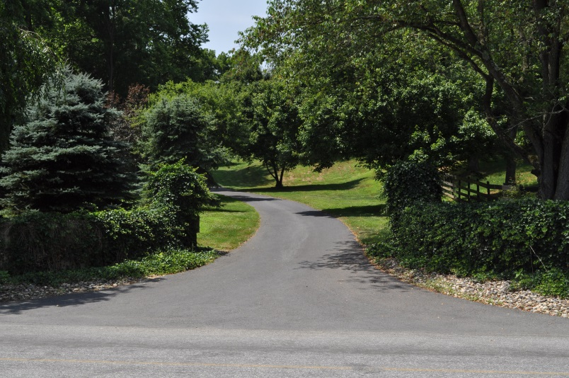vv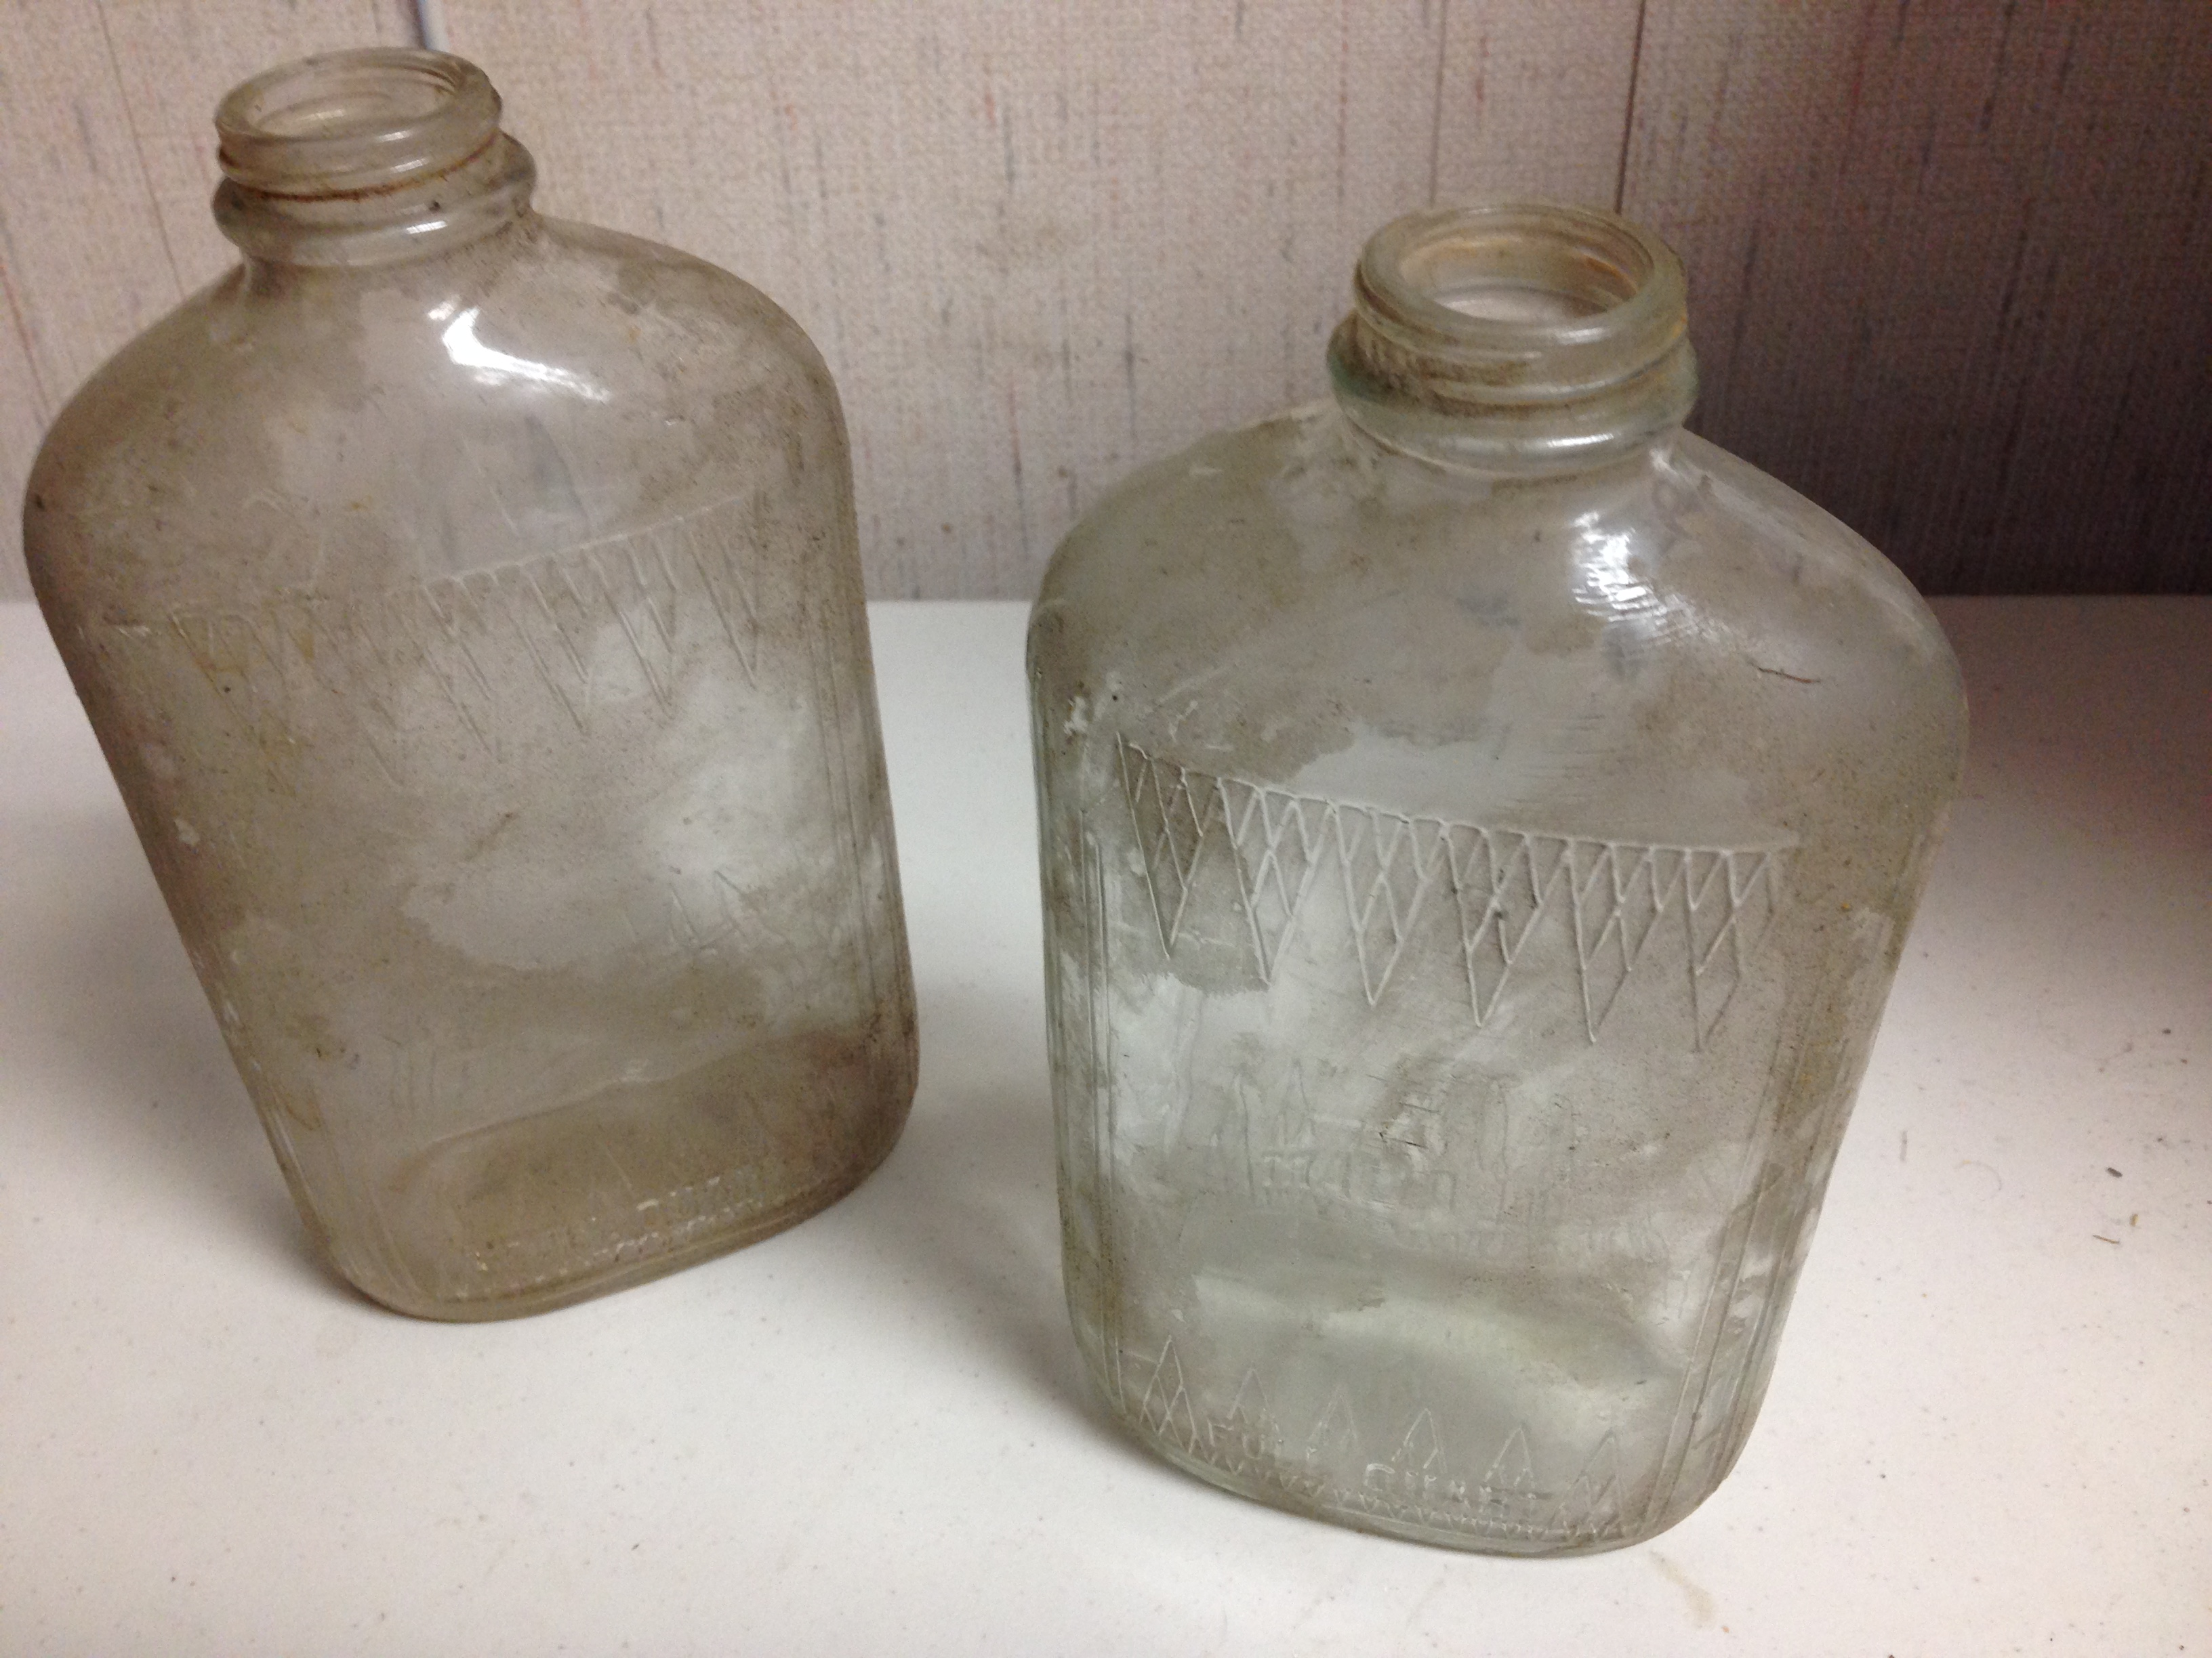

1009 Martindale Road, Martindale, Pa 17549

**Eby’s Store Public Auction**

Shurfine Inventory Reduction Sale, Antiques, Vintage Items and Groceries in Bulk Lots!

Subs,Soups,Baked Goods,and Eby’s salads available for dinner!

August 5th 5:00pm

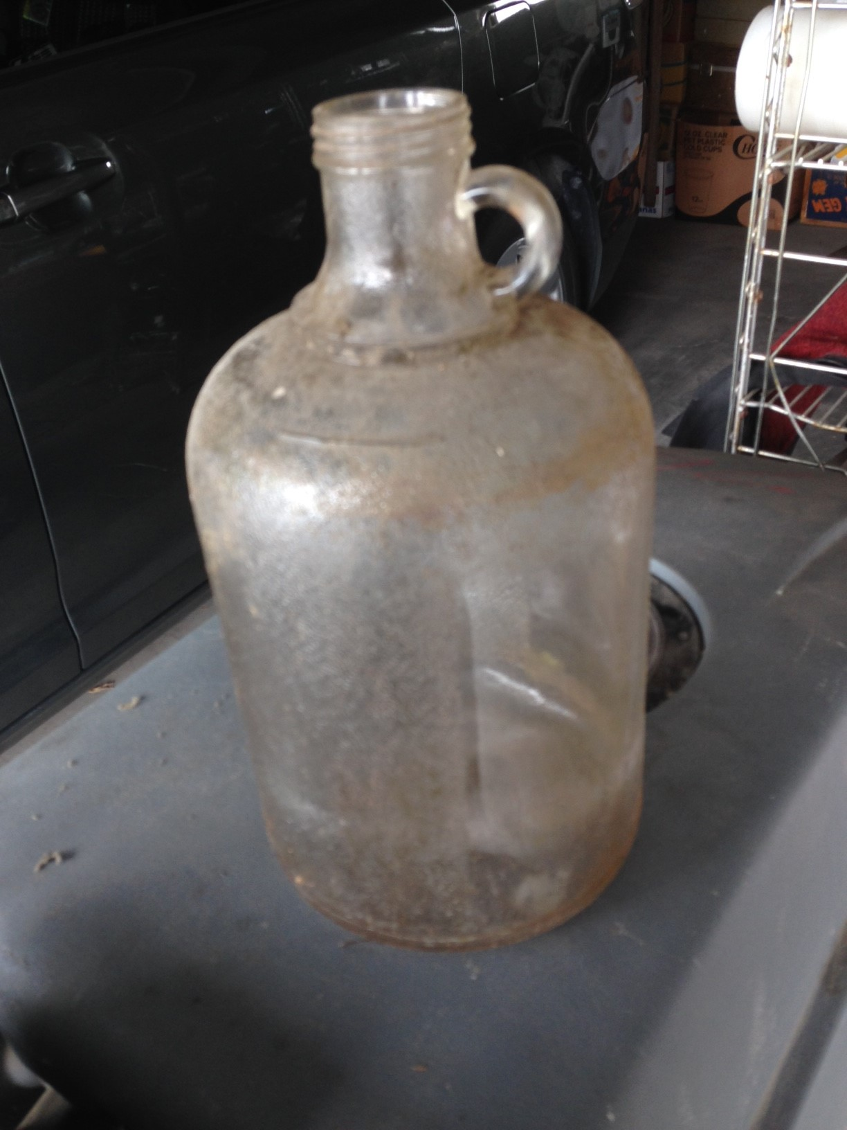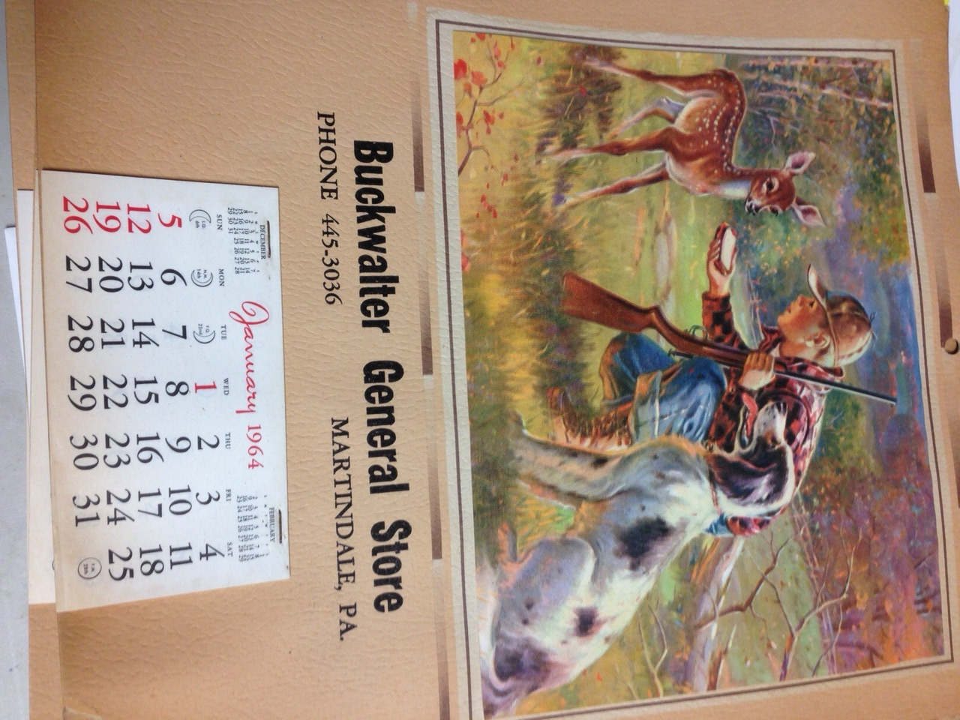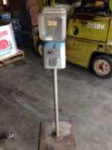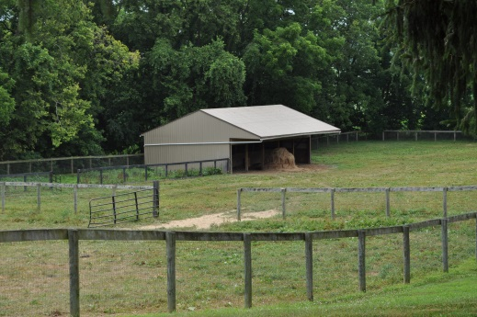

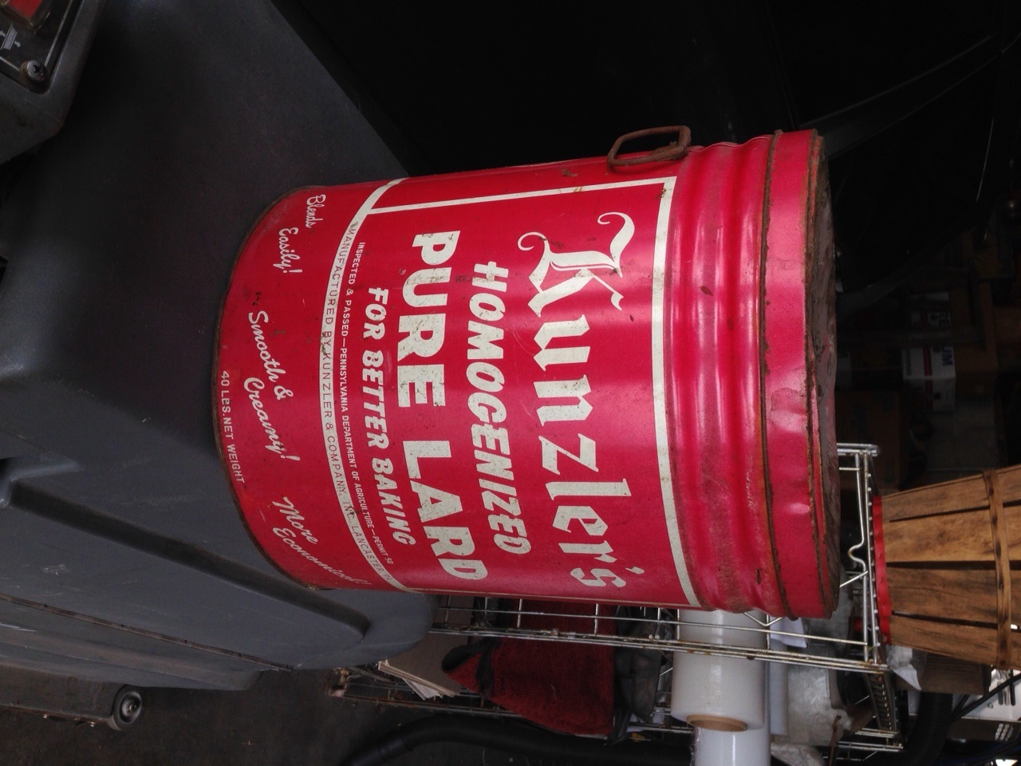

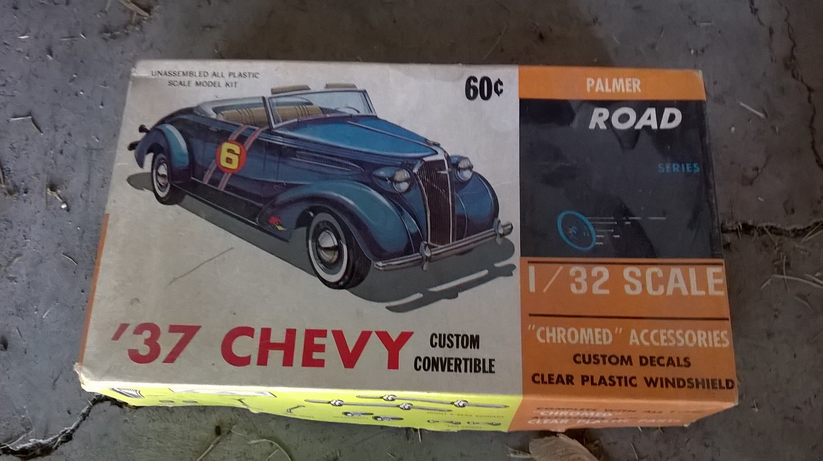

**Directions:** From Ephrata: Take 322 east to the light at Hinkletown (Next to Glenwood Foods). At the light make a left onto Martindale Road and follow Martindale road for 2.5 miles to Eby’s Store on the right.

From New Holland: Take 322 west to the light at Hinkletown (Next to Glenwood Foods). Make a right onto Martindale Road, Eby’s is 2.5 miles on the right.

**Vintage Items**: Glass bottles/jars, Old Lard cans, **Buckwalter General Store** 1960s calendars (50+), **Buckwalter’s Store** tablets, mason jars, early wooden chairs, Penny gumball machine, Green stamp machines, Green stamp rack, Diet-Rite Cola clock, **Groff’s** limited edition tins, **Bomberger’s** mince meat tin, wood keg, wood newspaper rack, chandelier, end table, Rapid Washers, **Nancy Drew, Cherry Ames, Donna Parker, Beverly Cleary, Happy Hollisters,** Devotions II for Early Teens (1961), To Kill a Mockingbird (1962), Tom Sawyer (1959), The Prince and the Pauper (1958), Mary Poppins (1962), and many, many other **books** from the 60s and 70s, Little Golden children’s books , Whitman children’s books (1967)and other hardcover children’s books (1960s), Highlights magazines (1972), Sports books (1960s, 70s), National Geographic Around the World Program sets (1960s), Ford GT, Beverly Hillbillies truck, AMX “390”, 1969 Corvette, ’37 Chevy Palmer, Lola lo riders, 37 Chevy amt, ’74 Vega, Little T monogram model cars

**New Merchandise**: Straw hats (5 varieties), Black wool hats, Panty hose, Winter gloves (kids and womens), Mens/Boys **Hanes** briefs, Mens Hanes white t’s, Mens socks, handkerchiefs, Womens/Girls Hanes briefs, Womens camis, Womens/girls socks, Diabetic socks, Spools of thread, Embroidery floss, Books, Note cards, Bias tape, Ribbon, 100+ zippers various colors/sizes, Paint brushes/rollers, Sandpaper, Masonry brushes, Work gloves, Grass shears

**Misc**: Tomato cages, Chicken wire, Tent, Thread display rack, Zipper display rack, Sandpaper display rack, window screening, No Hunting/Trespassing signs, Bug zapper,Garden Cart, Beds, Generator (in as is condition), Working Dryer, and Washer (in as is condition), Wood marble roller, Hiking back pack, 10a battery charger, Pressure cooker seal rings, Plastic crates, TV, Cash register, Microwave, Deep Sea Connie fishing pole, Duotherm oil burner stove (as is) and many more items.

**Bulk Groceries/Shurfine Groceries and many more hidden treasures that we have in our old building.**

Come on out for dinner as well. The Eby’s lunch wagon will have treats for dinner time during the auction.

**Auctioneers:**

**Noah Shirk AA#019471 717-354-0192**

**Peter A. Sensenig AA#005928 717-314-0698**

Seller(s): Nancy Portaro and Cory Ober

BEILER *-* CAMPBELL

**AUCTION SERVICES**

[**www.beiler-campbellauctions.com**](http://www.beiler-campbellauctions.com) **1-888-209-6160**