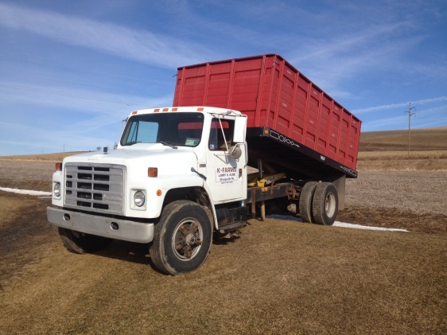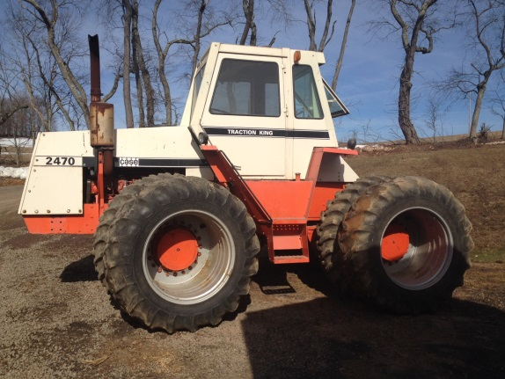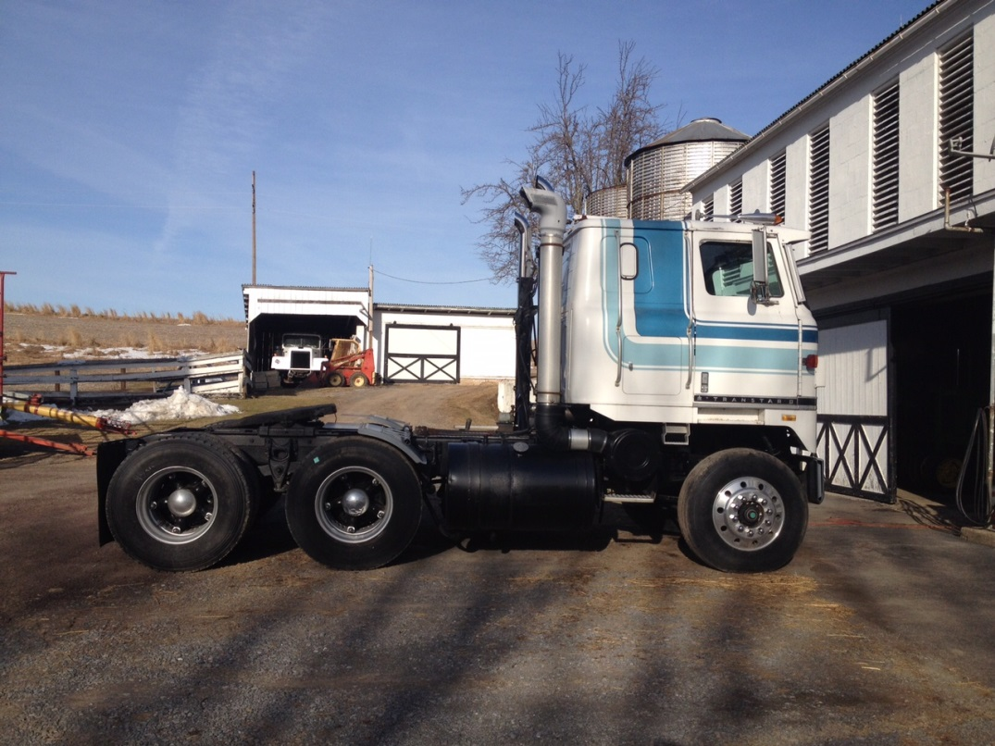C:\Users\owner\Documents\LOGO's\Pa Auction Logo.jpgC:\Users\owner\Documents\LOGO's\Pa Auction Logo.jpgC:\Users\owner\Documents\LOGO's\Pa Auction Logo.jpgC:\Users\owner\Documents\LOGO's\Pa Auction Logo.jpgC:\Users\owner\Documents\LOGO's\Pa Auction Logo.jpgC:\Users\owner\Documents\LOGO's\Pa Auction Logo.jpgC:\Users\owner\Documents\LOGO's\Pa Auction Logo.jpgC:\Users\owner\Documents\LOGO's\Pa Auction Logo.jpgC:\Users\owner\Documents\LOGO's\Pa Auction Logo.jpg



**Auctioneers: Jake Yoder**

**AU#005851 717-513-5386**

**J. Meryl Stoltzfus**

**AU#005403 717-629-6036**

**Seller: Larry Kline 570-336-6154**

**Trucks:** 1980 International Truck Tractor w/350 Cummins Motor, 10 Speed transmission & 3 position Jake Brake. Wet line hook up for dump trailer, 324,426 miles. Very nice condition. 1986 IH S1900 Dump Truck w/DT466 motor, 5 speed with 2 speed axel, grain body. Truck bus with 28’ bed, No title, farm use only.

**Tractor:** Case 2470 4wd w/Dual Wheels, overhauled last year and has 0 hrs. 3 point hitch, hydraulic outlets, no pto.

**Farm Equipment:** JD 348 sq baler w/#40 thrower; JD 8300 Drill; IH 5100 Drill; JD 1209 9’ Haybine;Westfield Elevator 8” Auger 51’; IH elevator with ear corn attach.; 10’ Elevator w/6” auger; AC 3000 series 6 bottom plow; Miller offset disk 10’; Brillion 13’ Cultimulcher; Graham 8’ Chisel plow; IH 720 7 bottom plows – on land; Liley Fertilizer spreader w/seed attachment; JD #7 Sycle Bar mower; NI manure spreader; NH 489 9’ Haybine; 500 gal. Spray tank on trailer.

**Trailers/Wagons:** 14’ flatbed trailer with title; 2 wood flatbed wagons; 2 wheel truck trailer

**Miscellaneous:** Wisconsin power unit – on wagon; JD 8’ scraper blade; 3 HP Air Compressor; 1000 gallon steel tank; lots of miscellaneous farm tools; parts; etc. to be sold in the morning.

**For additional pictures go to www.beiler-campbellauctions.com**

**Directions:** From I-80 take exit 236 Bloomsburg & turn right. Go 3.6 miles & turn left onto Charmund Rd. Go 0.5 mile & turn left onto Mt. Pleasant Rd. – Follow auction signs to location

BEILER *-* CAMPBELL

**AUCTION SERVICES**

[**www.beiler-campbellauctions.com**](http://www.beiler-campbellauctions.com) **1-888-209-6160**

280 Kline Road Orangeville, Pa. 17589

**Public Auction**

Trucks, Tractor, Farm Equip., Trailers/Wagons and more! May 16@ 9:00 A.M.