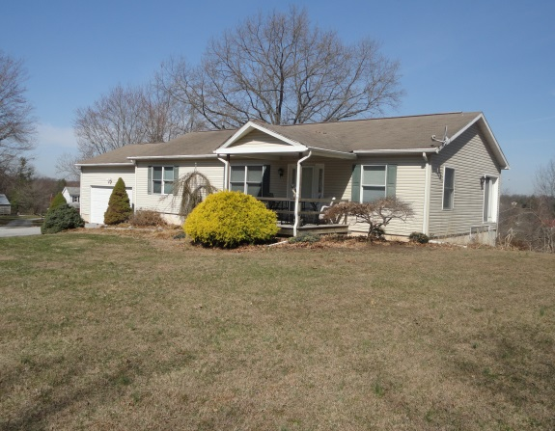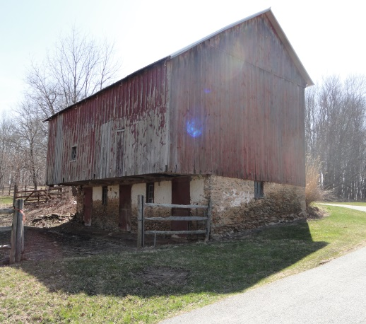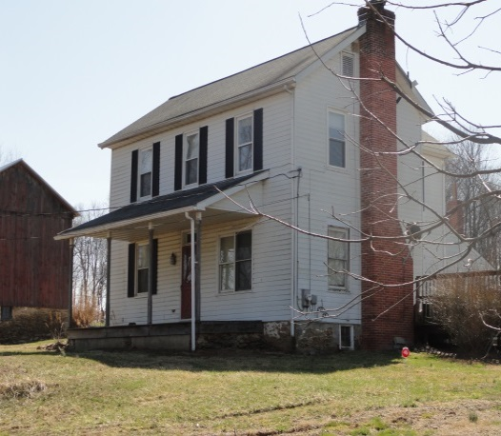C:\Users\owner\Documents\LOGO's\Pa Auction Logo.jpgC:\Users\owner\Documents\LOGO's\Pa Auction Logo.jpgC:\Users\owner\Documents\LOGO's\Pa Auction Logo.jpgC:\Users\owner\Documents\LOGO's\Pa Auction Logo.jpgC:\Users\owner\Documents\LOGO's\Pa Auction Logo.jpgC:\Users\owner\Documents\LOGO's\Pa Auction Logo.jpgC:\Users\owner\Documents\LOGO's\Pa Auction Logo.jpgC:\Users\owner\Documents\LOGO's\Pa Auction Logo.jpgC:\Users\owner\Documents\LOGO's\Pa Auction Logo.jpg

**Description:** 40 +/- acre farm with (2) Two Houses, Bankbarn and other outbuildings. House #1 Ranch Home House #2 Two Story Farm House Bankbarn with horse stalls Good combination of tillable, fenced pasture & wooded acreage (Good Timber), nice pond & stream with plenty of water on property, great Gentleman’s Estate, Equestrian Farm, Produce or cattle farm. Many possibilities!!

**Open House Dates:** *Thursdays: April 23rd; April 30th and May 7th* ***-* 4 to 7 pm** *Saturdays: April 25th and May 2nd* **-****1 to 4 pm*****Or call Auctioneer to schedule a private showing.***

**Terms:**  Down payment of $50,000 required day of sale. Settlement on or before July 31, 2015. Transfer Taxes to be paid by Buyer. Real Estate taxes to be prorated. Farm is in Act 319 “Clean and Green” but is not in Ag Preserve. Buyer shall be granted immediate possession of the ground if necessary for farming purposes. Taxes are $7,100.00 per/year.

**Attention Realtors:**  1% Broker participation being offered to Realtors who pre-register their buyers for the auction. Forms are available online at www.beiler-campbellauctions.com

**For additional pictures go to www.beiler-campbellauctions.com**

**Directions: Rt. 896 to Glenville Rd. to Right onto Rattlesnake Run to Farm on Right.**

**Public Auction**

Real Estate

40+/- Acre Farm (2) Two Houses, Barns & other Outbuildings

Wednesday May 20th @ 2:00 P.M.

310-316 Rattlesnake Run Cochranville, Pa. 19330 (Chester County)



**Auctioneer: Christ Taylor**

**AU#005421**

**717-371-1915**

**Seller: Mary Urbine**

BEILER *-* CAMPBELL

**AUCTION SERVICES**

[**www.beiler-campbellauctions.com**](http://www.beiler-campbellauctions.com) **1-888-209-6160**