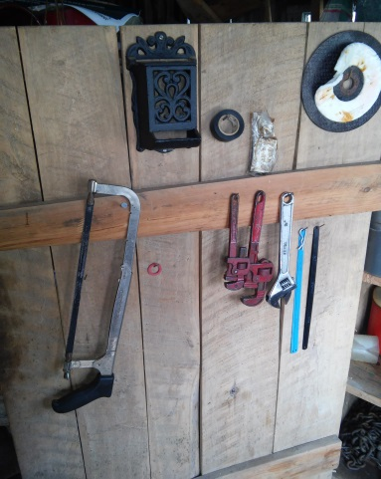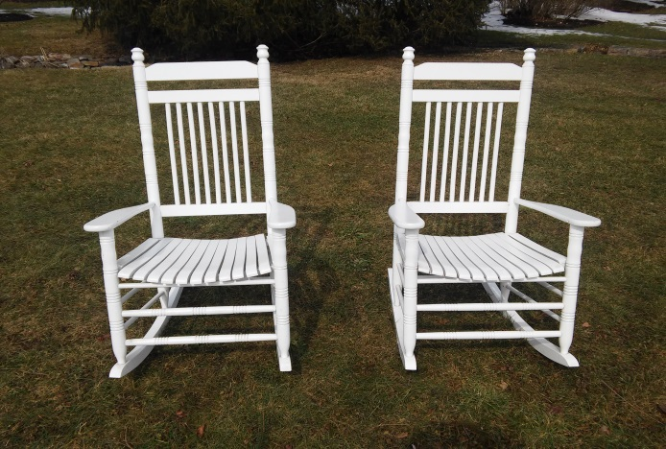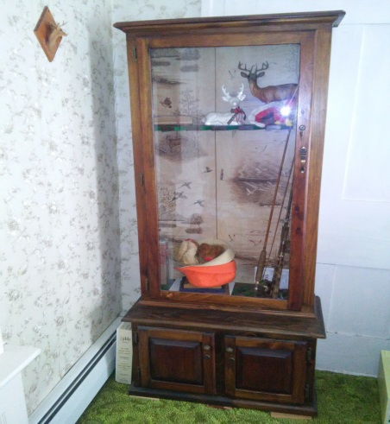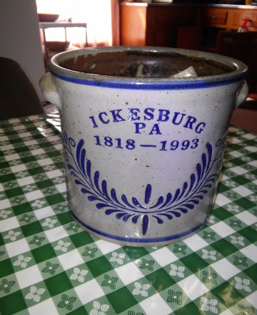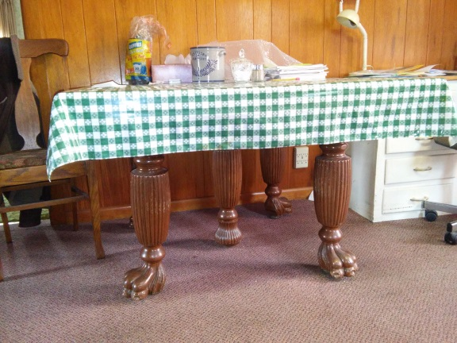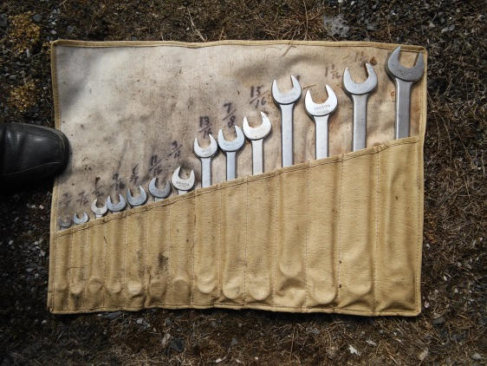C:\Users\owner\Documents\LOGO's\Pa Auction Logo.jpgC:\Users\owner\Documents\LOGO's\Pa Auction Logo.jpgC:\Users\owner\Documents\LOGO's\Pa Auction Logo.jpgC:\Users\owner\Documents\LOGO's\Pa Auction Logo.jpgC:\Users\owner\Documents\LOGO's\Pa Auction Logo.jpgC:\Users\owner\Documents\LOGO's\Pa Auction Logo.jpgC:\Users\owner\Documents\LOGO's\Pa Auction Logo.jpgC:\Users\owner\Documents\LOGO's\Pa Auction Logo.jpgC:\Users\owner\Documents\LOGO's\Pa Auction Logo.jpg

**Public Auction**

Tools, Lawn & Garden, Antiques, Household and Real Estate

Contents @ 9:00 AM Real Estate @ 1:00 PM

May 9, 2015

66 Tuscarora Path Ickesburg, Pa. 17037

**Directions: From (Ickesburg) the intersection of Rt. 74 & Rt. 17 take Rt. 17 West to second house on right.**

**Tools:** 7-drawer toolbox; Several wooden ladders; Trouble lights; Electric cords; 7 ¼” B&D skill saw; Air pump; Pump pliers; Industro 15 pc. Socket set; 14 pc. Industrial open end wrench set (standard); 15 pc. Metric wrench set; Crescent wrenches; Allen wrenches; Wrenches; Screwdrivers; Lots of misc. tools.

**Lawn & Garden:** Atlas 5 hp 20” snowblower; Lowe’s 12 hp 38” riding mover (new block 3 yrs. Ago); Troy-Built 6.5 hp 20’ push mower; Home N Yard electric leaf blower; Lots of misc. lawn and garden tools; Homelite 150 chainsaw; Wheelbarrow.

**Furniture, Antiques & Household:** 2 porch rockers; Metal egg basket, Blue jars w/zinc lids; Several early galvanized washtubs; Early bottle capper; ’93 Ickesburg crock; Early HB postage scales; Pioneer pocket balance scale; Seed sower; GE upright deep freezer; GE side-by-side refrigerator and freezer w/ice maker; Claw foot dining room extension table; Dining room table; Set of utensils – Orleans Silver; Set of American Limoges porcelain dishes – Lace Bouquet; Complete set of kitchenware; Gray agate bowl; Early LE jockey club – Binco; 2 early fly fishing rods; 3 air conditioners.

**For additional pictures go to** [**www.beiler-campbellauctions.com**](http://www.beiler-campbellauctions.com) **or Auctionzip.com ID#23383**



**Auctioneer:**

**J. Meryl Stoltzfus**

**AU#005403 717-629-6036**

**Seller: Cloyd A. Taylor, Sr.**

**Kathleen V. Taylor**

BEILER *-* CAMPBELL

**AUCTION SERVICES**

[**www.beiler-campbellauctions.com**](http://www.beiler-campbellauctions.com) **1-888-209-6160**