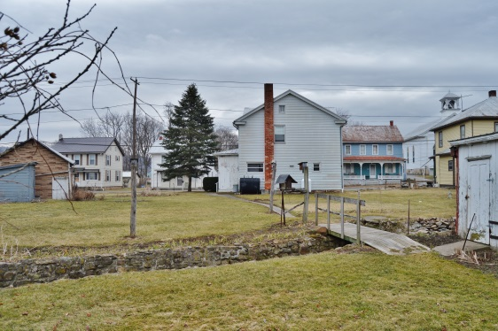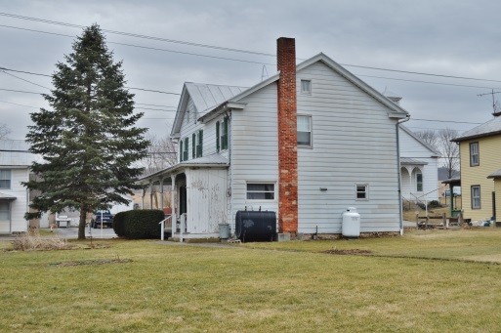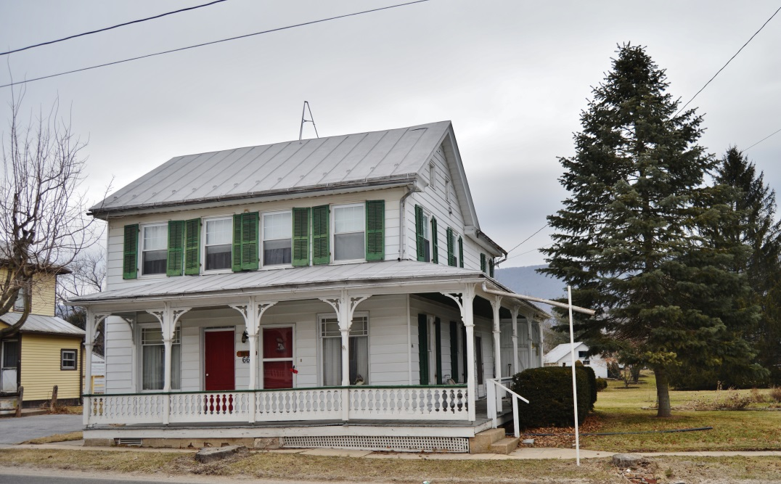C:\Users\owner\Documents\LOGO's\Pa Auction Logo.jpgC:\Users\owner\Documents\LOGO's\Pa Auction Logo.jpgC:\Users\owner\Documents\LOGO's\Pa Auction Logo.jpgC:\Users\owner\Documents\LOGO's\Pa Auction Logo.jpgC:\Users\owner\Documents\LOGO's\Pa Auction Logo.jpgC:\Users\owner\Documents\LOGO's\Pa Auction Logo.jpgC:\Users\owner\Documents\LOGO's\Pa Auction Logo.jpgC:\Users\owner\Documents\LOGO's\Pa Auction Logo.jpgC:\Users\owner\Documents\LOGO's\Pa Auction Logo.jpg

**Public Auction**

Perry County – Saville Twp.

4 Bedroom 1 ½ bath Two Story home on .28 acre

Contents @ 9:00 AM Real Estate @ 1:00 PM

May 9, 2015

66 Tuscarora Path Ickesburg, Pa. 17037

**Comments:** Two Story, 4 bedroom, 1 ½ bath home in downtown Ickesburg. Wrap around porch. Surprisingly spacious back yard, with towering shade trees and a little bubbling brook. Home is in good condition. First floor entails a spacious eat-in-kitchen, large pantry, living/family room with beautiful support colums, mudroom and a half bath. Second floor comprisers of 4 bedrooms, 1 full bath and laundry. Full walk up attic. Oil furnace, hot water w/cast iron baseboard. A total of 1,584 sq. ft. On-site well. Public Sever. 1 car detached garage and several garden sheds. Take a look at this home “in town” with a view of Tuscarora Mt. Don’t miss this opportunity to purchase from a motivated sellr.

**Open House Dates:** Thursday April 23rd 5:00 to 7:00 Call 717-629-6036 for more information or a private showing.

**Terms:** Settlement on or before June 24, 2015. $5,000.00 down payment on day of the auction. Transfer taxes to be paid by the buyer. Annual real estate taxes $1,54.60, these taxes to be pro-rated from settlement day.

**Attention Realtos:** 1% Broker Participation offered to Realtors with a buyer, your buyers must be preregisterd.

**For additional pictures go to** [**www.beiler-campbellauctions.com**](http://www.beiler-campbellauctions.com) **or Auctionzip.com ID#23383**

**For additional pictures go to www.beiler-campbellauctions.com**

**Directions: From (Ickesburg) the intersection of Rt. 74 & Rt. 17 take Rt. 17 West to second house on right.**



**Auctioneer:**

**J. Meryl Stoltzfus**

**AU#005403 717-629-6036**

**Seller: Cloyd A. Taylor, Sr.**

**Kathleen V. Taylor**

BEILER *-* CAMPBELL

**AUCTION SERVICES**

[**www.beiler-campbellauctions.com**](http://www.beiler-campbellauctions.com) **1-888-209-6160**