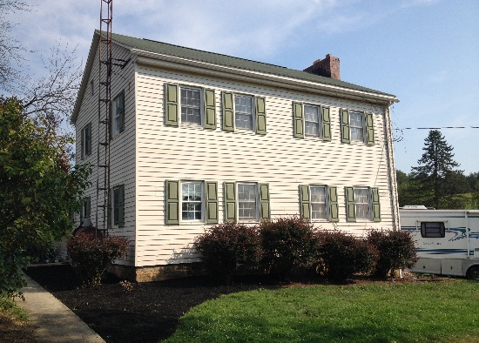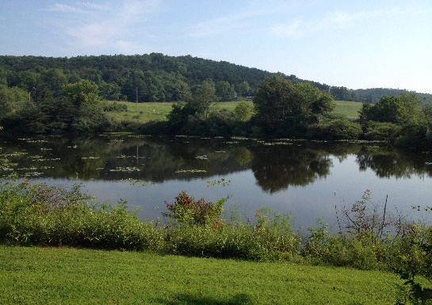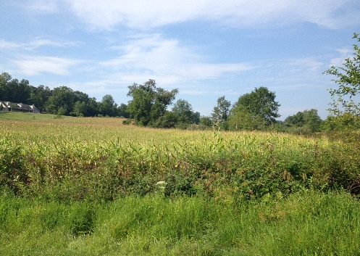C:\Users\owner\Documents\LOGO's\Pa Auction Logo.jpgC:\Users\owner\Documents\LOGO's\Pa Auction Logo.jpgC:\Users\owner\Documents\LOGO's\Pa Auction Logo.jpgC:\Users\owner\Documents\LOGO's\Pa Auction Logo.jpgC:\Users\owner\Documents\LOGO's\Pa Auction Logo.jpgC:\Users\owner\Documents\LOGO's\Pa Auction Logo.jpgC:\Users\owner\Documents\LOGO's\Pa Auction Logo.jpgC:\Users\owner\Documents\LOGO's\Pa Auction Logo.jpgC:\Users\owner\Documents\LOGO's\Pa Auction Logo.jpg

**Auctioneers:**

**Jake Yoder**

**AU#005851 717-513-5386**

**J. Meryl Stoltzfus**

**AU#005403 717-629-6036**

**Seller:**

**Richard Craig Estate**

**Seller:**

**Directions: Directions: From the traffic light in Middleburg turn left onto 522 & go approx. 4 miles to Royers Bridge Rd. Turn right & proceed to Kissimmee Rd. Turn left & go to Seiple Rd. Property on right. Watch for auction signs.**

**Real Estate:** Beautiful 58 acre farm consisting of 2 parcels.

**Parcel # 1**. 41.58 acres with approx. 15 acres open pasture/tillable land. Has a 2 story home that features 5 Bedrooms, 1 Bathroom, kitchen, living room, & basement. Heating options include wood, coal, or oil. Home is in a flood plain & current flood insurance is $702.00 per year. This parcel has a stocked 3 acre pond that offers great recreational opportunities. Woodland timbered approx. 8-10 years ago select cut & has white oak, red oak, & black oak among other species. This is a great opportunity to purchase a property for recreation or a permanent residence. This parcel may possibly be suitable for commercial poultry houses.

**Parcel # 2**. 17.07 acres mostly tillable land that currently has corn in fields. (Crops Excluded for 2015) Potential opportunities possibly include commercial poultry houses, renting out the fields, building your dream home & having your own small farm.

**Open House Dates:** Tuesday, Sept. 8 5:00-7:00 p.m. Saturday, Sept. 12 1:00-4:00 p.m.

**Terms of Sale:** These 2 parcels will be offered separately & as an entirety. If property is sold as entirety a deposit of $25,000.00 is required. If parcels are sold separately deposit amount of $15,000.00 is required on parcel #1 & a deposit amount of $10,000.00 on parcel #2. Transfer taxes to be split evenly between buyer & seller. Settlement to be on or before November 23, 2015

**Attention Realtors:** 1% Broker Participation offered to Realtors with a buyer. Your buyers must be pre-registered 48 hours prior to auction. **For more information or private showing contact: Jake Yoder – 717-513-5386**

**See future auction adds for detailed content list!**



BEILER *-* CAMPBELL

**AUCTION SERVICES**

[**www.beiler-campbellauctions.com**](http://www.beiler-campbellauctions.com) **1-888-209-6160**

479 Seiple Rd. Middleburg Pa 17842

**Public Farm Estate Auction**

**58 Acre farm - Tools, Lawn & Garden, & much more**

**Friday Afternoon October 9@ 1:00 Real Estate @3:00**