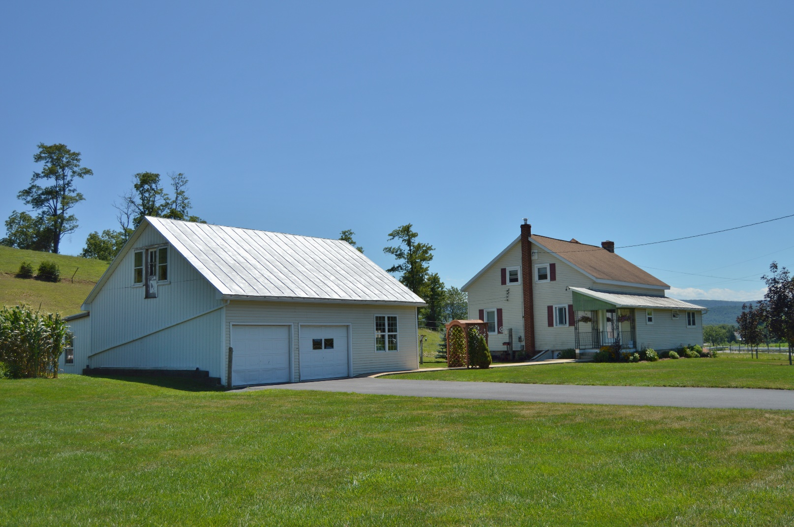C:\Users\owner\Documents\LOGO's\Pa Auction Logo.jpgC:\Users\owner\Documents\LOGO's\Pa Auction Logo.jpgC:\Users\owner\Documents\LOGO's\Pa Auction Logo.jpgC:\Users\owner\Documents\LOGO's\Pa Auction Logo.jpgC:\Users\owner\Documents\LOGO's\Pa Auction Logo.jpgC:\Users\owner\Documents\LOGO's\Pa Auction Logo.jpgC:\Users\owner\Documents\LOGO's\Pa Auction Logo.jpgC:\Users\owner\Documents\LOGO's\Pa Auction Logo.jpgC:\Users\owner\Documents\LOGO's\Pa Auction Logo.jpg

**Western Perry County home that was remodeled in 2009, 3 bedroom house, spacious kitchen, first floor master bedroom. Two stall horse barn, oversized two car garage/shop, & other outbuildings. Large vegetable garden, pasture for small or large animals. A 2+/- acre property that is well kept and in very good condition. Conveniently located close to town but not in town. Be prepared to purchase, seller is motivated.**

**Open House: August 25th 5:00 to 7:00. Call 717-629-6036 for more information or a private showing.**

**Terms: Settlement on or before October 30, 2015. $10,000.00 down payment on the day of the auction. 2% transfer tax to be paid by the buyer. Real Estate taxes to be prorated from settlement day. Attention Realtors: 1% Broker Participation offered to Realtors with a buyer, your buyers must be preregistered.**

**For additional pictures go to www.beiler-campbellauctions.com**

**Directions: From Rt. 322 at Millerstown take Rt. 17 W approx. 20 mi. to property on left.**

**Auctioneer: J. Meryl Stoltzfus**

**AU#005403**

**717-629-6036**

**Sellers:**

**David & Emma Jane Fisher**

**Public Real Estate Auction**

2 +/- Acres• 3 Bedroom House • Horse Barn

September 15th @ 6:30 P.M.

551 Blain Road Blain, Pa. 17006



BEILER *-* CAMPBELL

**AUCTION SERVICES**

[**www.beiler-campbellauctions.com**](http://www.beiler-campbellauctions.com) **1-888-209-6160**