

**Property Description:**  38.69 acres of mostly tillable farmland. Property is currently being used for crop land. Terrain lies from level to slight rolling. A nice piece of farmland that can be used for agricultural purposes, or to build your dream home on. Property was subdivided in 2006 into 4 parcels with approved perc tests for each parcel. Perc tests are still valid & acceptable to Adams Township SEO. On auction day the property will be offered by parcel & as the entirety. If you are looking for more farmland or a parcel to build a home on come prepared to buy. Property is located close to Faylor Lake. An ideal location for the avid fisherman. Parcels are listed & described below. Parcels are listed according to survey map.

**Parcels #3, 4, & 5:** Each of these parcels are 6+ acres vacant tillable land with approved perk tests. They all have 300+ feet of road frontage along Middle Rd. Choose which one is your favorite & come prepared to buy.

**Parcel #1:** 20.035 acres vacant mostly tillable land with approved perc test. This parcel lies to the north side of property & can be accessed either by Herman Rd. or Middle Rd. This parcel has a Commonwealth of Pennsylvania Flowage Easement through a portion of it.

**Real Estate Taxes:**  $437.18

**Terms of Sale:**  These 4 parcels will be offered separately & as an entirety. If property is sold as entirety a deposit of $25,000.00 is required. If parcels are sold separately deposit amount of $5,000.00 is required on parcel #3, 4, & 5. A deposit amount of $10,000.00 on parcel #1. Transfer taxes to be split evenly between Buyer & Seller. Settlement to be in 60 days or before.

**Attention Realtors:**  1% Broker Participation offered by seller to Realtors with a buyer. Your buyers must be pre-registered 48 hours prior to auction.

**For more information or private showing contact: Jake Yoder – 717-513-5386**

**Auctioneers: Jake Yoder AU#005851 717-513-5386**

**Attorney: Thomas C. Clark 570-837-0092**

**Seller:**

**Directions:** From stop light in Middleburg take Rt. 104 toward Mifflinburg. Go approx. 3 miles & turn left onto Middle Rd. Go 6 miles to property on right. Property is also approx. 2.5 miles from Rt. 235. Watch for auction signs.

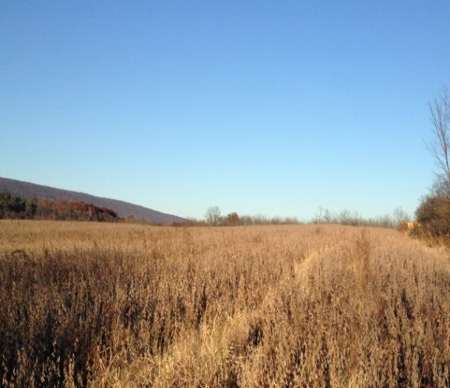

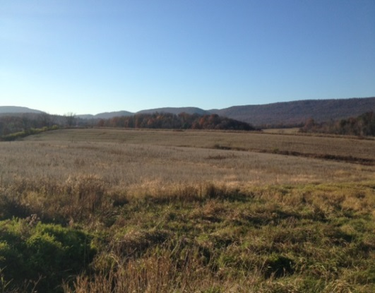

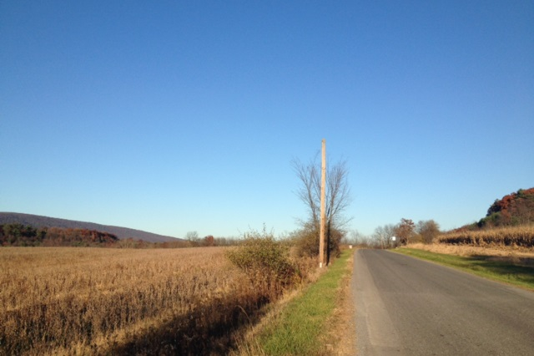



BEILER *-* CAMPBELL

**AUCTION SERVICES**

[**www.beiler-campbellauctions.com**](http://www.beiler-campbellauctions.com) **1-888-209-6160**

**00 Middle Rd. Middleburg, Pa. 17842**

**Public Real Estate Auction**

**38.69 acres farm land – mostly tillable**

**Saturday December 12 @ 11:00 A.M.**