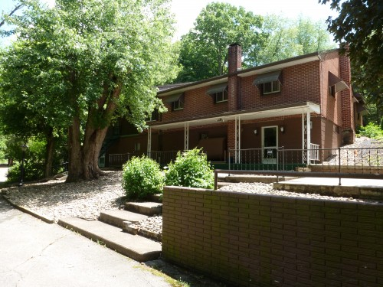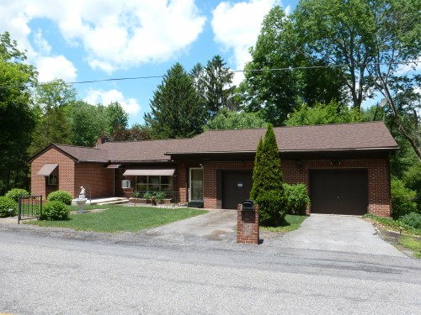

**Public Real Estate Auction**

0.86 Acres• 2 Bedroom Ranch House

Juniata County, PA

March 31st @ 5:30 P.M.

**Directions: From Rt. 322 at Thompsontown take Rt. 333 to the auction on the right.**

18231 Rt. 333 Port Royal, Pa. 17082

**"Get-away Retreat" or a "Permanent Dwelling" In Juniata County. Close in proximity to River Fishing and Tuscarora Wild Area State Forest! Updated two bedroom brick ranch home with wrought iron & brick fenced yard, 0.86 acre. Totally remodeled kitchen with custom built 2011 Crownwood cabinets. Daylight, walkout finished basement hosts the second kitchen. Plus, a family room with dry bar for entertaining. Warm up to Kodiak woodstove at brick hearth. Lower level laundry offers shower and sink conveniences. Recent roof and furnace replacements. Two car attached garage. Workshop/ Man Cave under rear porch. Easy to heat! This 1950's house is very well maintained and is in move-in condition. Enjoy nature while relaxing on the private rear porch, under the mature shade trees, or in the enclosed breezeway. Easy access to this property that is approx. 4 miles from Rt. 322. Real Estate taxes are $902.23 a year.**

**Auctioneers Note: Mrs. McNemar is now residing in an elderly care home, so the sellers are very motivated to sell. Do not miss this opportunity to purchase a home that has been extensively updated since 2011. Records on file of recent inspections and updates.**

**Open House: February 20th 1:00 to 4:00 & March 8th 5:00 to 7:00. Call 717-629-6036 for more information or a private showing.**

**Terms: Settlement on or before May 31, 2016. $5,000.00 down payment on the day of the auction. 2% transfer tax to be paid by the buyer. Real Estate taxes to be prorated from settlement day.**

**Attention Realtors: 1% Broker Participation offered to Realtors with a buyer, your buyers must be preregistered.**

**For additional pictures go to www.beiler-campbellauctions.com**

**Auctioneer: J. Meryl Stoltzfus**

**AU#005403**

**717-629-6036**

**Sellers: Helen M. McNemar, POA Galene Sellers**



BEILER *-* CAMPBELL

**AUCTION SERVICES**

[**www.beiler-campbellauctions.com**](http://www.beiler-campbellauctions.com) **1-888-209-6160**