For C:\Users\owner\Documents\LOGO's\Pa Auction Logo.jpgC:\Users\owner\Documents\LOGO's\Pa Auction Logo.jpgC:\Users\owner\Documents\LOGO's\Pa Auction Logo.jpgC:\Users\owner\Documents\LOGO's\Pa Auction Logo.jpgC:\Users\owner\Documents\LOGO's\Pa Auction Logo.jpg

**Public Auction**

**Farm Equipment, Shop & Automotive tools, Parts and more**



BEILER *-* CAMPBELL

**AUCTION SERVICES**

[**www.beiler-campbellauctions.com**](http://www.beiler-campbellauctions.com) **1-888-209-6160**

Saturday February 13th@ 9:00 A.M.

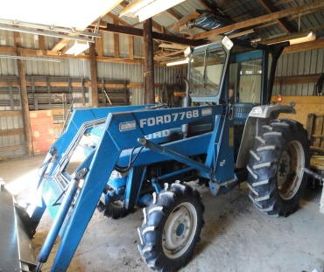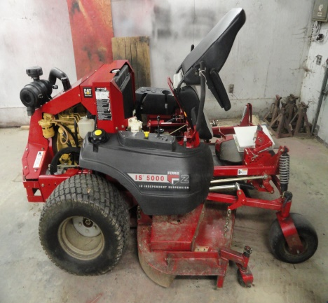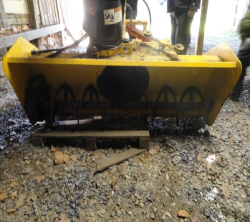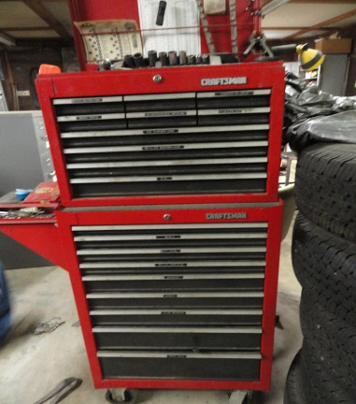

**DIRECTIONS: Rt. 272 to East on Pennsy Road to right on Sawmill Road to Sale on right. OR Rt.222 To Main Street (New Providence) to west on Pennsy Rd. to left onto Sawmill Rd. to sale on left.**

**Farm Equipment**: Ford 2110 4WD tractor w/Ford 776B loader & 6’ bucket & Sims cab **(1332 hrs.) with reserve**; **Ferris IS5000Z** zero-turn mower w/3 cyl Cat diesel, 72” cut, full suspension **(145 hrs.)** Nice; Ford 3pt 8’ flail mower; Erskine 72” 3pt snow blower w/hyd. Chute; Ford 3pt 8’ blade; 5’ 3pt rotary mower; 3pt concrete weight; 8’ pull type disc; 8’ Brillion cultipacker; Ford 2 bottom plow; 3pt spreader; tire chains. **Shop & Automotive Tool:** Silver Beauty 145 mig welder w/tank & cart; Lincoln 225 stick welder; P/tron 20 plasma cutter; 25 ton hyd. shop press; HDI floor model drill press w/vise; Pacemaker 5 hp 2 stage air compressor; 5 hp electric pressure washer; Redi-Kleen parts washer; Skat Blast bead blaster on cart w/Craftsman vac.; FMC 7100 tire changer; small sand blaster; Bishman 570 wheel balancer; 2 ton engine hoist; 2 floor jacks 1.5 ton; hyd. power pack; small scroll saw; table saw; B&D polisher; metal welding table w/vise; bench grinder; battery chargers; kero & electric heaters; bearing & wheel pullers; barrel pumps; cable winch; 5 rolls .030 mig wire; welding rods; pipe vise; jack stands; tap & die sets; creepers; torch kit; torch hoses & heads; work lights on reels; micrometer; dial indicator; heli coil kit; 5 air paint sprayers & lots of paint and painting supplies, cleaners, thinners, hardeners, accelerators; electric power tools, saws, grinders, sanders, drills, heat & soldering gun’ air tools, chisel w/bits, sander, drill, saw, ½” impact, 3/8 “ air wrench; grease guns; electric tester; drill bits; Craftsman tool box; ½” & ¼” socket set; ½” impact socket set; lots of hand tools, wrenches, pliers, clamps, screw drivers, hammers, Allen wrenches, pipe wrenches; misc. electrical supplies, switches, crimps, wires, fittings & many other items, too numerous to list! **Automotive Parts:** 352 CU IN Ford engine; Ford 460 engine; 14 hp Kohler engine; 4 alum. Rims; ’65 Ford truck parts including fuel tank, grill with light s & doors; misc. automotive books & manuals; 5 tires LT 275/70R18; misc. filters, lots of new hose clamps; organizer w/brass fittings; trailer jack; metal oil & gas cans. **Misc:** 300 gal fuel tanks w/hand pump;200 gal fuel tank w/electric pump; wood stove; 5’ cross cut saw blades; air conditioners; box fan; bag cart; clay trap thrower w/box clays; 8’ wood step ladder; fork; ax; digging iron; sledge hammer; 14’ aluminum ramp; 10’ panel gate; misc. PVC pipe; misc. lumber; homemade wood sled; 2 large filters; small animal cage; wire fence; fence posts; old wooden barrels; garage door opener; like new dish washer; scaffold sections; walnut log 8’ long 30” dia. w/crotch; fishing rods, tackle box and waders; 4 pcs ½ OSB; yard spreader; metal wheelbarrow; metal watering can; 2 motors; metal shelving; misc. bolts, nuts, washers, lags, screws, nails, scrap steel & much more! **Special Mention**: All items Absolute except for the Ford 2110 4WD Tractor which will be sold w/reserve. Items garage kept. Come and enjoy the day. Auction to be held inside in case of inclement weather. **For additional pictures go to AuctionZip.com ID#38803**

**Auctioneers:**

Christ Taylor

AU#005421

717-371-1915

**Seller:**

David S. Wild

Joanne Wild

(And the late Jim Wild)

**Seller:**