C:\Users\owner\Documents\LOGO's\Pa Auction Logo.jpgC:\Users\owner\Documents\LOGO's\Pa Auction Logo.jpgC:\Users\owner\Documents\LOGO's\Pa Auction Logo.jpgC:\Users\owner\Documents\LOGO's\Pa Auction Logo.jpgC:\Users\owner\Documents\LOGO's\Pa Auction Logo.jpg

**Public Auction**

**Truck, Tractors, Farm Equip., Trailers, Tools & More!**

**Saturday April 9th @ 9:00 a.m.**



BEILER *-* CAMPBELL

**AUCTION SERVICES**

[**www.beiler-campbellauctions.com**](http://www.beiler-campbellauctions.com) **1-888-209-6160**

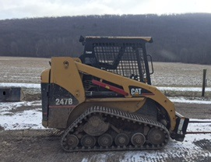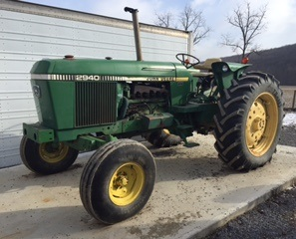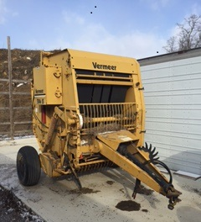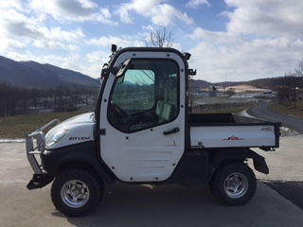

**DIRECTIONS:** From Turnpike take Bedford exit 146. Turn Right onto Business 220; Go .3 miles and turn Right onto Weber Lane. Go 1 mile and turn Left onto Country Ridge Road. Go .3 miles, turn Right onto Lincoln Hwy. Go 1.7 miles to Auction on Left. Auction conducted at Kauffman Metals. Watch for signs!

6146 Lincoln Hwy. Bedford, Pa. 15522

**Farm Equipment:** 2940 JD diesel diesel tractor; 3750 Kuboda 4 wheel drive tractor; 247B Cat diesel skid loader on almost new tracks; lNissan 5000 lb. propane fork life w/side shift; Cat 2000 lb. electric fork lift w/side shift; 1360 John Deere discbine 9’; 10 ft. White disk w/cylinder; 3 bottom White semi mount plow w/coulters & cylinder; 16 ft. Brillion cultipacker; New Holland hay rake w/front casters; New Idea manure spreader; Vemeer 504s round baler twine; Small cattle trailer; Skid loader trailer; 14 ft. Moritz gooseneck dump trailer; skid loader snow bucket, sweeper w/catch bucket; bucket to pick rocks; 4 ft. forks; under fence trimmer by motor; bale speer; grapple forks; mount for 6 ft. brush hog why motor; safety cage for skid loader or fork lift; 3 pt. 12 ft. spring tooth harrow; 3 pt 6 ft. land prider rototiller; heavy 6 ft. roller; 3 pt. 6 ft. brush hog; 3 pt fertilizer spreader; Kubota 1100 rtv diesel,4 wheel drive, full cab, heat, air, power dump, snow plow, 2011; 2008 Polaris Ranger XP 700, full cab, wipers, heater, 4 wheel drive; Cushman trickster, full cab, wipers, heater, pto, power dump; 20 ft. push on bale feeder on wheels; 2 round bale feeders. **Shop Equipment & Tools:** Car towing dolly; PTO generator on cart; Wheel barrow; Electric concrete mixer –like new; 36” Power concrete trawler w/Honda engine; Honda concrete screet w/fiber glass edgers; Concrete bull float w/6 extension handles; 3 concrete come alongs; Easy clean 4000 high pressure, hot washer, washer; Honda high pressure washer; 2 water tanks; 40 gas. Fuel tank w/12 volt pump & battery; 50 gas. Gas tank w/hose, uses air pressure to pump out; Laser transit w/case & attachments; Millermatic 250 mig welder w/tank; Torch set w/tanks on cart; Power Max XP 440e Generator, electric start; 3 portable air compressors; Floor model drill press; 10” Craftsman radial arm saw; 10” miter saw; 14” chop saw; Hitachi 10” table saw; Power steel band saw; Drill Doc electric drill bit sharpener; Small propane heater w/tank; 2 chain saws; 170T Reddy space heater; Large shop vac; 12 volt weed sprayer; 2 electric table top grinder; Mastermind double tool box on wheels; Craftsman tool box on wheels; Revolving bolt bin; small refrigerator; Hydraulic jack; lots of log chains, chain binders, cable come alongs and power tools; 6’ and (2) 8 ft. step ladders; assorted length aluminum ladders; lots of different carts on wheels; boxes of parts, bolts, nails, paints, different oil and engine treatments; a few skids of lumber, glass board, paneling, plywood; steel, angles, flats, tubing; head tri flex wire; elec. Push thru cattle gate; Hy tensile wire w/unwrapper on skid, new; 2 sets of loading ramps; 100 lb. propane tank full of gas; plastic pallets; Vet Gun Co fired balls to treat cattle for flies; 12 volt Lincoln grease gun w/charger; Steel welding table w/vice; ¾” socket set in case; 2 – 12” air wrenches; rolls of bale wrap, 34”; HY tensile fencing parts; Lg. shop fan on pedestal; 3 pair size 11 work boots; 4 – 55 gal. barrels (1 w/some 1-40 oil & pump); 1 – 55 gal. barrel w/drain oil; casters & wheels; urn Multi head crimp tool set for Plex pipe; Handyman jack; Wheeled line painter; Ridgid orbital jigsaw; Ridgid hammer drill; Makita 3 “ planer; Dewalt 18 volt Angle drill; 18 volt set, drill, circular saw, recip. Saw; Dewalt 18 volt set, drill, impact driver; Century 200 amp Battery Charger; Schumacher 200 amp Battery Charger **Lawn & Garden:** JD 1145 diesel, 4 wheel drive, front mount, lawn mower, 72”; Simplicity riding tractor w/48” deck; small push lawn mower; 50” lawn sweeper; Honda water pump – used to irrigate. **Truck:** 1997 Ford Ranger , 4 WD, good condition **Guns:** Marlin 30/30 lever action rifle w/scope; Remington 22 pump w/scope & some shells **Household Items;** Electric organ; computer desk and chair; Kneehole desk and chair; 4 chrome padded kitchen chairs; recliner; 7 ft. wooden bench; Kirby sweeper w/shampooer and all attachments; some lights and miscellaneous stands; lots of books. **Auctioneers Note:**  After 35 years in Bedford the Kauffman’s are having auction due to relocating to Lebanon, Pa. Lots of quality items to choose from & everything sells ABSOLUTE. Make sure to set the date aside & come support the auction. Lunch Stand will be provided.

**Auctioneers:**

**Jake Yoder**

**AU#005851**

**717-513-5386**

**Seller:**

**Abner S. & Anna K. Kauffman**

**Seller:**