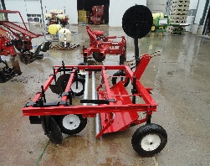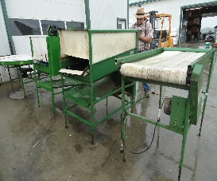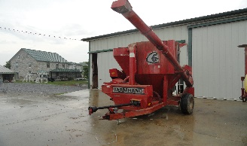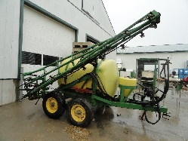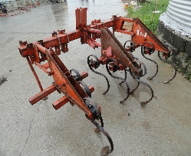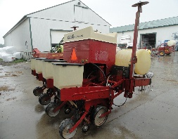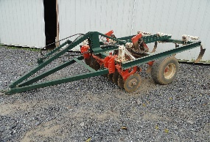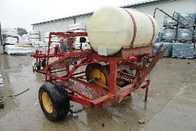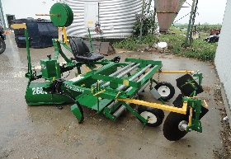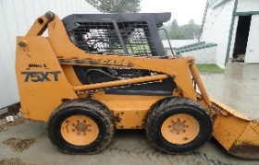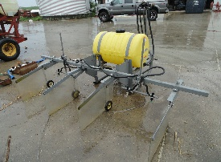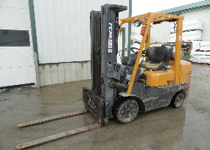Picture border

**Directions: From Route 222, take Route 772 east to right onto Stone Quarry Rd to auction on left.**

**From Route 23, take Route 772 west to left onto Stone Quarry Rd to auction on left.**

**Farm Equipment:** Case 75XT Skid loader, 1725 hrs. w/ aux hyd. & 7’ material bucket, very nice; TCM 25 4300 LBS LP forklift, 3 stage mast w/ side shift 4000 hrs. (1 owner); NH 320 small sq. baler w/ thrower; CIH 900 4-row cyclo air planter w/ liq. Fert., corn & bean drums; Farmhand 817 grinder mixer w/ 3 screens; Glenco 5 shank chisel plow w/ disc & hyd. lift; IH 720 4 bottom semi-mount auto reset plow; Athens 12’ transport disc; NH 790 harvester w/ NH 824 2-row head; IH 130 forage wagon; Hesstan 7322 forage wagon; Zimmerman 40’ bale elevator; I & J 3-point 2 row cultiv.; JM Shirk 3-point 3 tooth auto reset subsoiler; Iva 3PT 300 gal. sprayer w/ foam markers & 30’ manual booms; JD gear w/ext. tongue; bin wagon; 4 steel belting wheels 8 lug 14” x 35”; 7’ skid loader bucket; bale spear; 42” full taper forklift forks; new & used 5500# pallet jacks.

**Produce Equipment:** Iva Mfg. 500 gal. 26’ hyd. lift & fold single sided boom sprayer, tandem axle w/ rinse tank & John Blue 580 PSI pump, manual valves & 4-way nozzles; Crop Care 55 gal. 3PT shielded row sprayer w/ 10’ boom; Rainflo 2600 series 2 raised bed plastic layer w/ auto tracking & double drip tape attachment; Nolt’s 4’ plastic layer; JM Shirk 3PT auto reset plastic lifter; Nolt’s vegetable water wheel planter 3PT or pull type; Rainflo 2600 plast. layer w/ auto track; Rainflo 1800 Challenger 3 pt. plast. lifter;

3 PT. Rainflo 1600 Series 2 water wheel transplanter w/12”, 18 “, 24“ & 36” water wheels; 28’ Aluminum hyd. drive produce conveyor; JM Shirk 3PT plastic wrapper; AZS Brusher veg. washer, w/ 5’ round sort table, 4’ infeed conveyor & custom built inline watermelon brusher unit; 5-transplanter water wheels; 100’of ft. row covers & wire hoops; 100+ plastic 5/8 bushel baskets; lots of 40” wooden stakes; new & used 3’ & 4’ ground cover; ground cover staples.

**Irrigation Equipment:** Cadman 2625 traveling irrigation unit w/ new Honda rewind engine & app 950’ of 3” hose & Nelson gun; Caprari D3-50 4” PTO irrigation pump; Ford 6-cylinder gas engine w/ Gorman-Rupp 4” model 54B pump on trailer; 60-new 4” x 20’ SDR 26 PVC 160 PSI underground pipes; 2-Honda GX200 engines w/ 2” self-priming high pressure pumps; 2-sand filter unit w/fert. injectors; 100’s of ft. 1 ½”, 2”, 3” & 4” lay flat hose; 7-rolls 7500’ drip tape; lots of fittings for lay flat hose & drip tape.

**Greenhouse & Misc. Parts & Supplies:** 10-collapsible bins 40” x 48” x 24” high; lots of misc. 4” pipe fittings, tees, 45 & 90 deg. elbows & couplers; new & used gravel bags; 16’ x 48’ greenhouse frame (disassembled) w/ roll new plastic; 2-propane heaters; 2-circulating fans; exhaust fan; 4’ digital pallet scale.

161 Stone Quarry Road Leola, PA 17540 – Lancaster County

**Public Auction**

**Farm, Produce & Irrigation Equipment; TCM Forklift,**

**Case 75XT Skidloader & Greenhouse Supplies**

**Sat. December 3, 2016, @ 9:00 A.M.**

**Auctioneers Notes: Be Prompt!** **Not many small items. Also taking consignments for Greenhouse, Produce & Irrigation Equipment. Call Noah Shirk 717-354-0192 or Elvin Fox 717-656-7046 to consign or for more information. Call by Nov 5th for free advertising**. For additional pictures go to [www.beiler-campbell.com](http://www.beiler-campbell.com) or [www.auctionzip.com](http://www.auctionzip.com).



**Auctioneers:**

**Christ Taylor: 717-371-1915** AU#005421

**Noah Shirk 717-354-0192** AU#005928

**Harold Martin: 717-738-4228** AA#019488

**Seller: Elvin Fox**

BEILER *-* CAMPBELL

**AUCTION SERVICES**

[**www.beiler-campbellauctions.com**](http://www.beiler-campbellauctions.com) **1-888-209-6160**